**DIGITAL SYSTEMS**

**PRACTICUM 9**



**By:**

**ARIA WIDIYO NOVIYANTO**

**NIM: L200183043**

**INFORMATION TECHNOLOGY**

**FACULTY OF COMMUNICATION AND INFORMATICS**

**UNIVERSITY OF MUHAMMADIYAH SURAKARTA**

**Experiment 1**

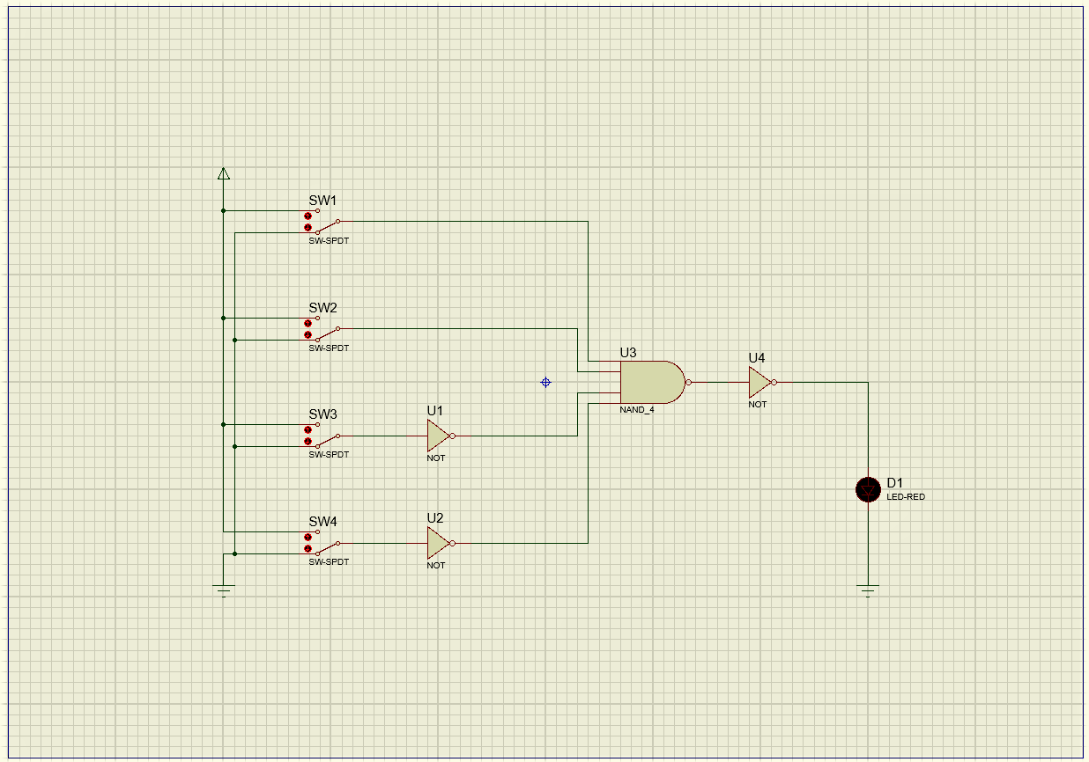

Picture 1.1.Set of decoder

1. Column table

|  |  |  |  |  |
| --- | --- | --- | --- | --- |
| **A** | **B** | **C** | **D** | **F** |
| 0 | 0 | 0 | 0 | 0 |
| 1 | 0 | 0 | 0 | 0 |
| 0 | 1 | 0 | 0 | 0 |
| 1 | 1 | 0 | 0 | 1 |
| 0 | 0 | 1 | 0 | 0 |
| 1 | 0 | 1 | 0 | 0 |
| 0 | 1 | 1 | 0 | 0 |
| 1 | 1 | 1 | 0 | 0 |
| 0 | 0 | 0 | 1 | 0 |
| 1 | 0 | 0 | 1 | 0 |
| 0 | 1 | 0 | 1 | 0 |
| 1 | 1 | 0 | 1 | 0 |
| 0 | 0 | 1 | 1 | 0 |
| 1 | 0 | 1 | 1 | 0 |
| 0 | 1 | 1 | 1 | 0 |
| 1 | 1 | 1 | 1 | 0 |

1. Decoder (F) only works (ON) when: A = 1, B = 1, C = 0, and D = 0.
2. Set of decoder that has output as a function: F = 1, if condition A = 0, B = 1, C = 1, D = 1. (F = A'BCD)

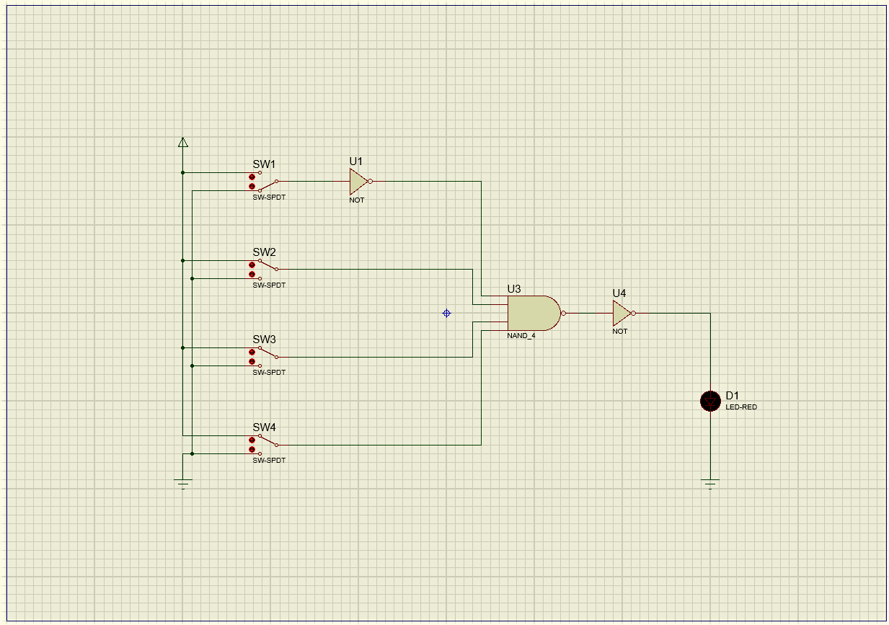

Picture 1.2. Set of decoder

**Experiment 2**

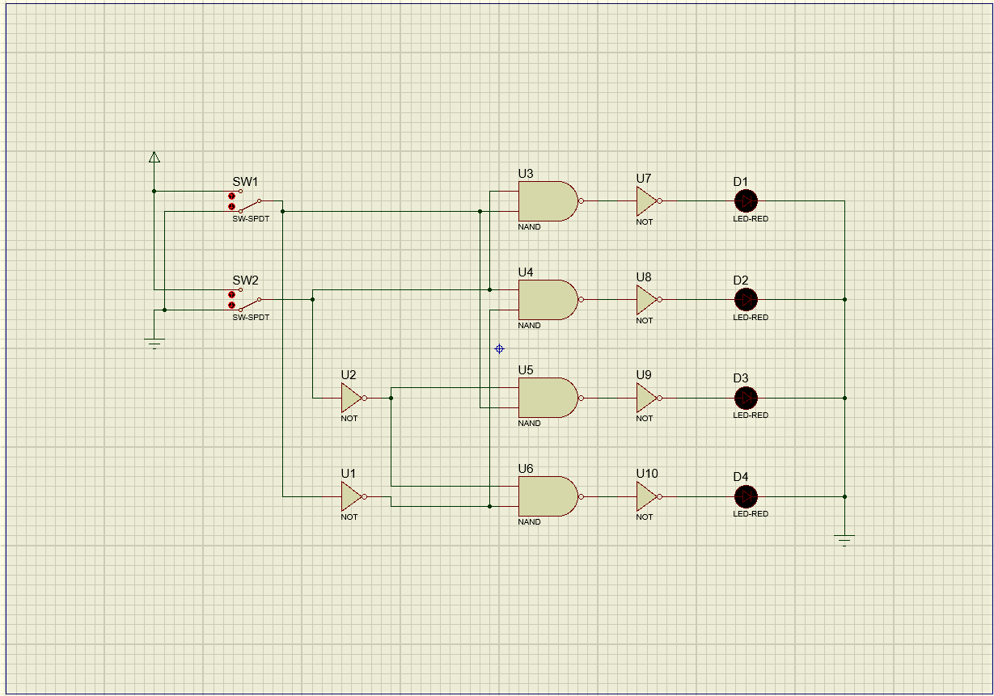

Picture 2.1. Logic gate combination

1. Column table

|  |  |  |  |  |  |
| --- | --- | --- | --- | --- | --- |
| **Input** | | **Output LED** | | | |
| **SW1** | **SW2** | **D1** | **D2** | **D3** | **D4** |
| 0 | 0 | 0 | 0 | 0 | 1 |
| 0 | 1 | 0 | 1 | 0 | 0 |
| 1 | 0 | 0 | 0 | 1 | 0 |
| 1 | 1 | 1 | 0 | 0 | 0 |

1. Output result from the logic gate combination
   1. D1 = SW1 . SW2
   2. D2 = $\overline{SW1}$. SW2
   3. D3 = SW1 . $\overline{SW2}$
   4. D4 = $\overline{SW1}$. $\overline{SW2}$

**Experiment 3**

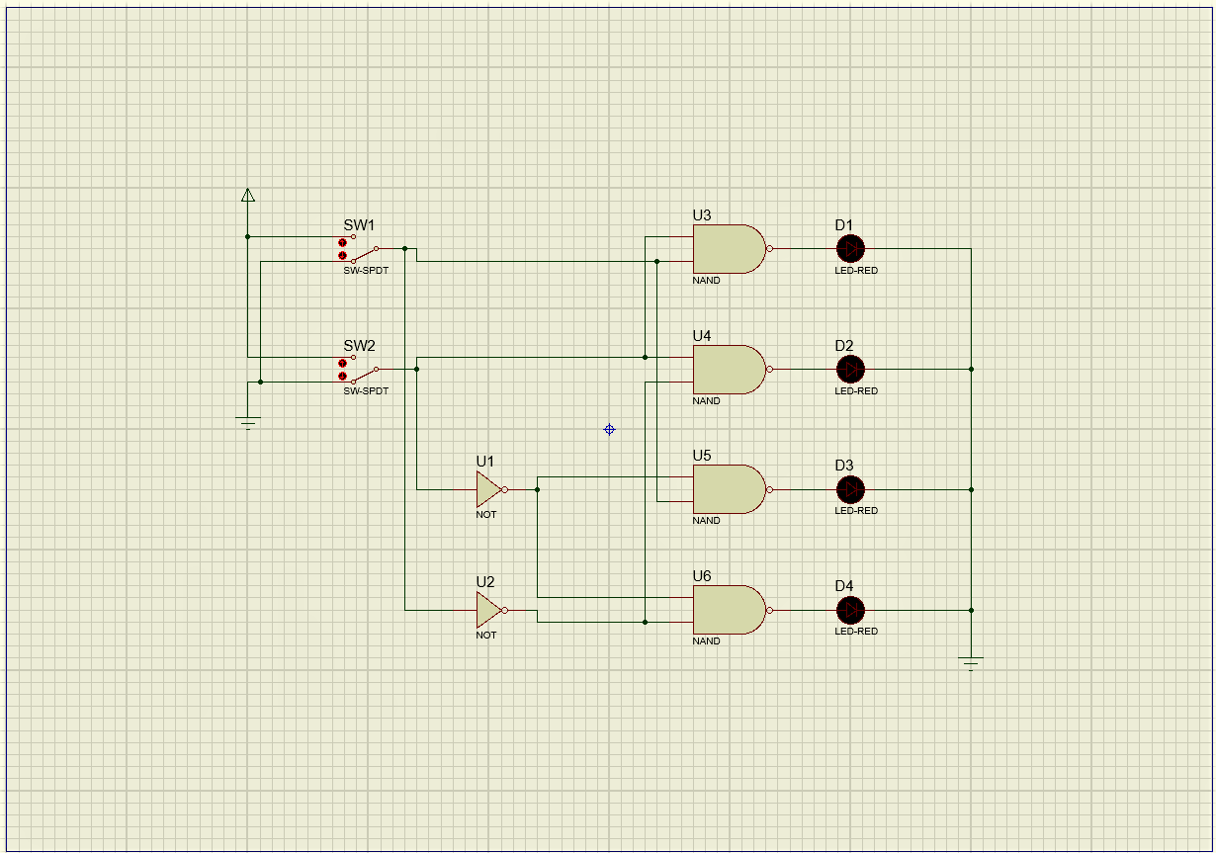

Picture 3.1. Logic gate combination

1. Column table

|  |  |  |  |  |  |
| --- | --- | --- | --- | --- | --- |
| **Input** | | **Output LED** | | | |
| **SW1** | **SW2** | **D1** | **D2** | **D3** | **D4** |
| 0 | 0 | 1 | 1 | 1 | 0 |
| 0 | 1 | 1 | 0 | 1 | 1 |
| 1 | 0 | 1 | 1 | 0 | 1 |
| 1 | 1 | 0 | 1 | 1 | 1 |

1. Output result from the logic gate combination
   1. D1 = SW1 . SW2
   2. D2 = $\overline{SW1}$. SW2
   3. D3 = SW1 . $\overline{SW2}$
   4. D4 = $\overline{SW1}$. $\overline{SW2}$
2. Conclusion from experiment 2 and 3

in the second experiment there is a NOT gate located after the NAND gate, while in the third experiment there is no NOT gate located after the NAND gate. so the output results in experiments 2 and 3 are very different

**Experiment 4**

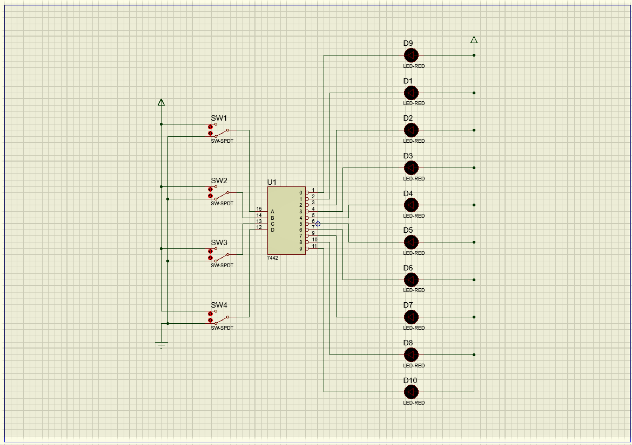

Picture 4.1. Common anode LED circuit

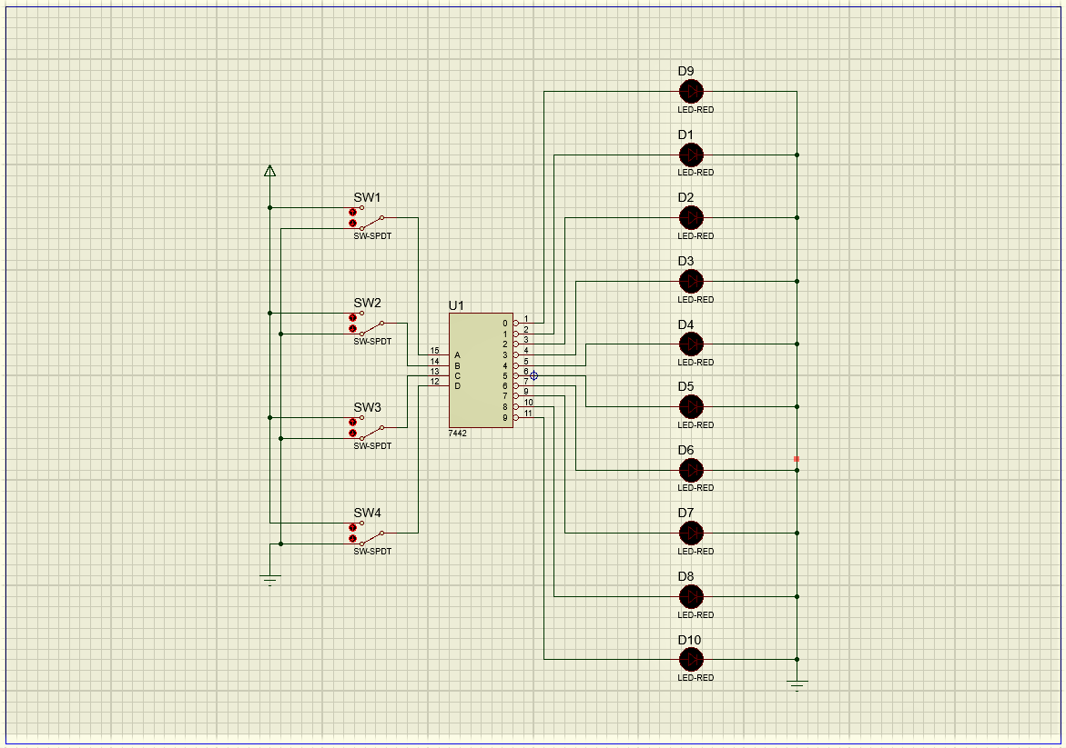

Picture 4.2. Common cathode LED circuit

1. Column table
   1. Common anode LED

|  |  |  |  |  |  |  |  |  |  |  |  |  |  |
| --- | --- | --- | --- | --- | --- | --- | --- | --- | --- | --- | --- | --- | --- |
| **Input** | | | | **Output** | | | | | | | | | |
| **SW1** | **SW2** | **SW3** | **SW4** | **1** | **2** | **3** | **4** | **5** | **6** | **7** | **8** | **9** | **10** |
| 0 | 0 | 0 | 0 | 1 | 0 | 0 | 0 | 0 | 0 | 0 | 0 | 0 | 0 |
| 1 | 0 | 0 | 0 | 0 | 1 | 0 | 0 | 0 | 0 | 0 | 0 | 0 | 0 |
| 0 | 1 | 0 | 0 | 0 | 0 | 1 | 0 | 0 | 0 | 0 | 0 | 0 | 0 |
| 1 | 1 | 0 | 0 | 0 | 0 | 0 | 1 | 0 | 0 | 0 | 0 | 0 | 0 |
| 0 | 0 | 1 | 0 | 0 | 0 | 0 | 0 | 1 | 0 | 0 | 0 | 0 | 0 |
| 1 | 0 | 1 | 0 | 0 | 0 | 0 | 0 | 0 | 1 | 0 | 0 | 0 | 0 |
| 0 | 1 | 1 | 0 | 0 | 0 | 0 | 0 | 0 | 0 | 1 | 0 | 0 | 0 |
| 1 | 1 | 1 | 0 | 0 | 0 | 0 | 0 | 0 | 0 | 0 | 1 | 0 | 0 |
| 0 | 0 | 0 | 1 | 0 | 0 | 0 | 0 | 0 | 0 | 0 | 0 | 1 | 0 |
| 1 | 0 | 0 | 1 | 0 | 0 | 0 | 0 | 0 | 0 | 0 | 0 | 0 | 1 |
| 0 | 1 | 0 | 1 | 0 | 0 | 0 | 0 | 0 | 0 | 0 | 0 | 0 | 0 |
| 1 | 1 | 0 | 1 | 0 | 0 | 0 | 0 | 0 | 0 | 0 | 0 | 0 | 0 |
| 0 | 0 | 1 | 1 | 0 | 0 | 0 | 0 | 0 | 0 | 0 | 0 | 0 | 0 |
| 1 | 0 | 1 | 1 | 0 | 0 | 0 | 0 | 0 | 0 | 0 | 0 | 0 | 0 |
| 0 | 1 | 1 | 1 | 0 | 0 | 0 | 0 | 0 | 0 | 0 | 0 | 0 | 0 |
| 1 | 1 | 1 | 1 | 0 | 0 | 0 | 0 | 0 | 0 | 0 | 0 | 0 | 0 |

* 1. Common cathode LED

|  |  |  |  |  |  |  |  |  |  |  |  |  |  |
| --- | --- | --- | --- | --- | --- | --- | --- | --- | --- | --- | --- | --- | --- |
| **Input** | | | | **Output** | | | | | | | | | |
| **SW1** | **SW2** | **SW3** | **SW4** | **1** | **2** | **3** | **4** | **5** | **6** | **7** | **8** | **9** | **10** |
| 0 | 0 | 0 | 0 | 0 | 1 | 1 | 1 | 1 | 1 | 1 | 1 | 1 | 1 |
| 1 | 0 | 0 | 0 | 1 | 0 | 1 | 1 | 1 | 1 | 1 | 1 | 1 | 1 |
| 0 | 1 | 0 | 0 | 1 | 1 | 0 | 1 | 1 | 1 | 1 | 1 | 1 | 1 |
| 1 | 1 | 0 | 0 | 1 | 1 | 1 | 0 | 1 | 1 | 1 | 1 | 1 | 1 |
| 0 | 0 | 1 | 0 | 1 | 1 | 1 | 1 | 0 | 1 | 1 | 1 | 1 | 1 |
| 1 | 0 | 1 | 0 | 1 | 1 | 1 | 1 | 1 | 0 | 1 | 1 | 1 | 1 |
| 0 | 1 | 1 | 0 | 1 | 1 | 1 | 1 | 1 | 1 | 0 | 1 | 1 | 1 |
| 1 | 1 | 1 | 0 | 1 | 1 | 1 | 1 | 1 | 1 | 1 | 0 | 1 | 1 |
| 0 | 0 | 0 | 1 | 1 | 1 | 1 | 1 | 1 | 1 | 1 | 1 | 0 | 1 |
| 1 | 0 | 0 | 1 | 1 | 1 | 1 | 1 | 1 | 1 | 1 | 1 | 1 | 0 |
| 0 | 1 | 0 | 1 | 1 | 1 | 1 | 1 | 1 | 1 | 1 | 1 | 1 | 1 |
| 1 | 1 | 0 | 1 | 1 | 1 | 1 | 1 | 1 | 1 | 1 | 1 | 1 | 1 |
| 0 | 0 | 1 | 1 | 1 | 1 | 1 | 1 | 1 | 1 | 1 | 1 | 1 | 1 |
| 1 | 0 | 1 | 1 | 1 | 1 | 1 | 1 | 1 | 1 | 1 | 1 | 1 | 1 |
| 0 | 1 | 1 | 1 | 1 | 1 | 1 | 1 | 1 | 1 | 1 | 1 | 1 | 1 |
| 1 | 1 | 1 | 1 | 1 | 1 | 1 | 1 | 1 | 1 | 1 | 1 | 1 | 1 |